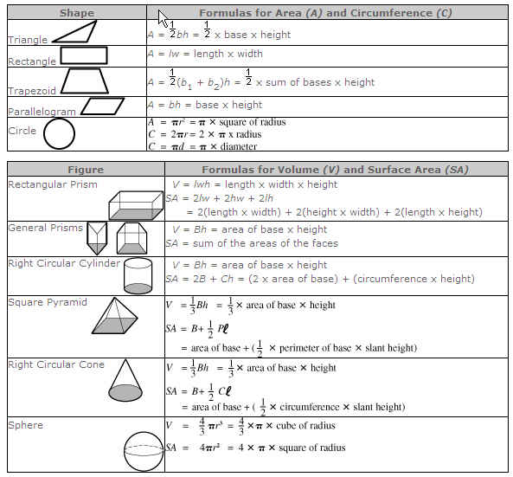
- Use this sheet as a tool for your independent and self directed work. Document ALL steps required
- You may use a calculator but you must list formula used for every solid object you are quantifying
- You must show a drawing of some kind to illustrate the object you are quantifying
  - Multi-view
  - Oblique
  - Isometric
- Drawings must be clear and proportionally accurate, labeled and with proper line weights
- Dimensions must be clear and correct to 3 decimal places (thousandths of an inch)
- This is a major grade for the semester involving components of all lessons thus far:
  - Measurement
  - Scale drawing
  - Dimensioning
  - Cooperation
  - Punctuality

